## Leveraging External Data with BCS

**Lab Time**: 60 minutes

**Lab Folder**: C:\Student\Labs\BCS

**Lab Overview:** In this lab you will work with External Content Types (ECT). ECTs expose line of business application data directly to the end user. You will use SharePoint Designer 2010 in order to create the ECT and all of the operations that can be executed on it. You will then expose the data as an External List in SharePoint and then connect that list to Outlook so end users can manage the contacts data in a familiar Office application. Furthermore, you will learn how you can use the Quick Parts functionality in Microsoft Word to directly surface line of business application data.

Lab Setup Requirements

* Before you begin this lab, you must run the batch file named **SetupLab.bat**. This batch file creates a new blank site collection at the location **http://intranet.wingtip.com/sites/BCS**.

### Exercise 1: Creating External Content Types in SPD

External Content Types are the foundation of BCS applications. External Content Types represent the business objects in the external data that you would like to use in your application. In this exercise, you will use the SharePoint Designer (SPD) to create entities based on the **AdventureWorks** database.

1. Start **SharePoint Designer 2010** (SPD) and click **Open Site** and enter **http://intranet.wingtip.com/sites/BCS**. You may need to login when prompted. If so, use the **administrator** account.
2. After the site opens in, click **External Content Types** in the left-hand pane. Give SPD a moment to build the list of existing entities, which should be empty at this point.
3. When the entity report completes, click the **External Content Type** button in the **New** group on the ribbon.
4. Use the following to update the **External Content Type**:

**Display Name:** Contact

**Programmatic Name:** Contact

**Namespace:** AdventureWorks

**Office Item Type:** Contact

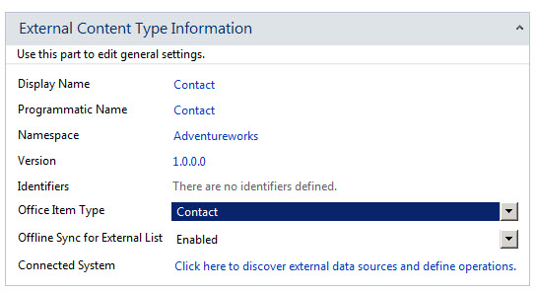

1. On the ribbon, click the **Operations Design View** button in the **Views** group.
2. On the **Contact** tab, click the **Add Connection** button.
3. In the **Select Your Data Source Type** dialog, select **SQL Server** and click the **OK** button.
4. In the **SQL Server Connection** dialog, use the following and click **OK**:

**SQL Server**: WingtipServer

**Database Name:** AdventureWorks

**Name (optional):** AWConnection

Choose **Connect with User’s Identity**

1. Expand the **AWConnection** node and the **Tables** folder and select the **Contact** table.
2. Right-click the **Contact** table, and select **Create All Operations** from the context menu.

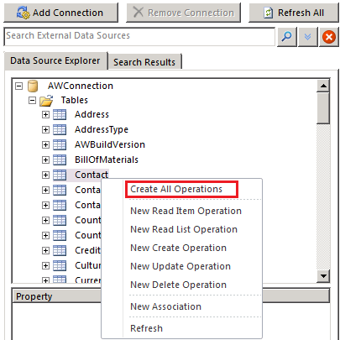

1. After clicking **Create All Operations**, SharePoint Designer will launch a wizard which leads you through three pages.
2. The first page is the **Operations Properties** dialog. There should be no errors or warning on this page. Click the **Next** button.
3. The second page is the **Parameters Configuration** dialog. There should be several warnings and an error. Move through the following steps to correct the error and two of the warnings.
   1. In the list of **Data Source Elements**,select the **LastName** field.
   2. In the **Office Property** drop-down list, select **Last Name (LastName)**.
   3. **Check** the **Show In Picker** checkbox.
   4. Repeat the above process to associate the **First Name**, **Email** and **Phone** to their Office properties (ignore the show in picker option).

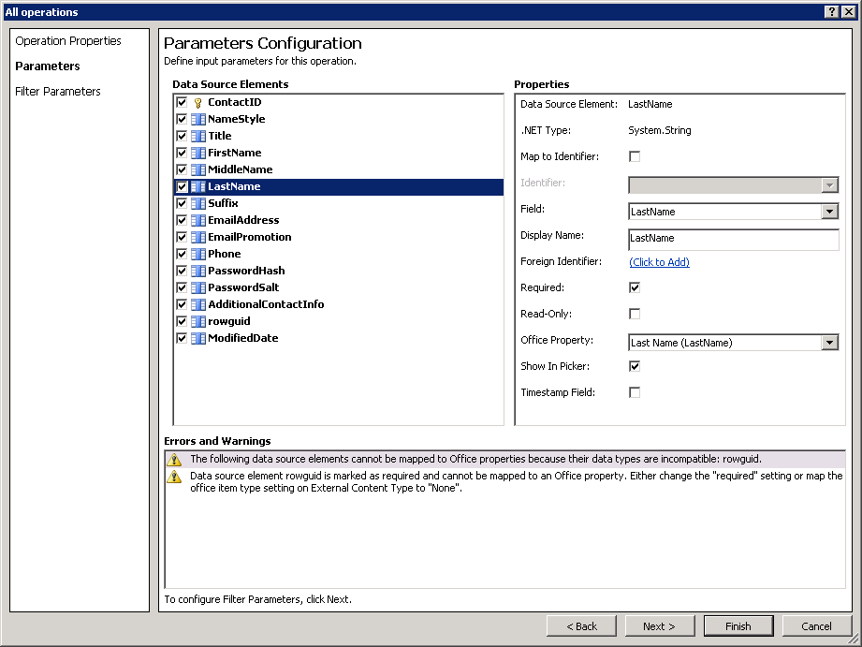

* 1. While there are still two warnings about the **rowguid** field, you can ignore them.
  2. Click the **Next** button.

1. In the **Filter Parameters Configuration**, do the following:
2. Click the **Add Filter Parameter** button to add a new **Query Parameter**.
3. Click the **Click to Add** link to add a new filter.

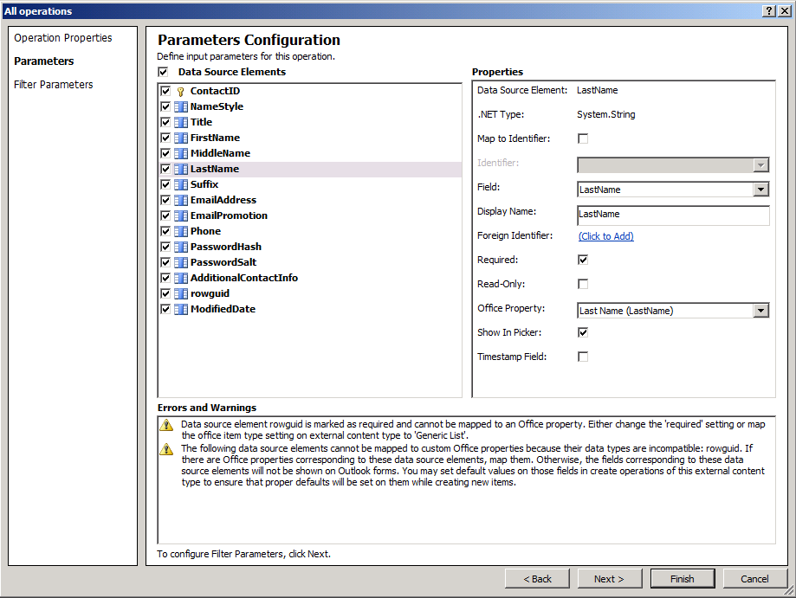

* 1. Add a new **Limit** filter and click the **OK** button. A limit filter is required to ensure that the records returned do not exceed the 2000 item throttling limit imposed by BCS.

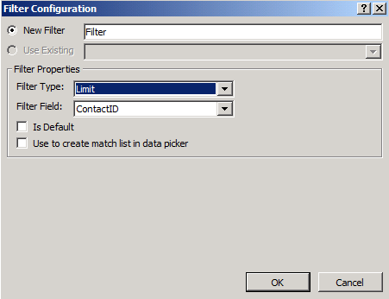

* 1. Click on **Default Value** field on the **Filter Configuration** screen and type in **100**.

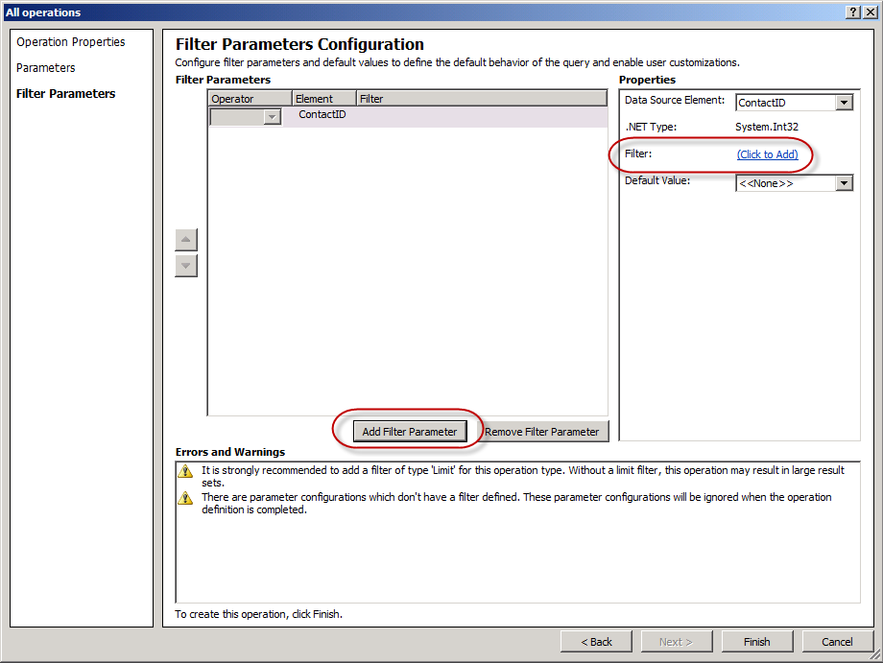

* 1. Click the **Finish** button to complete the wizard.

1. Now you must save the **Contact** external content type. You can accomplish this by clicking the **Save** button at the top of the SharePoint Designer ribbon in the Quick Access Toolbar (disk icon) when the tab for the **Contact** external tab has focus.
2. Now it is time to create a new external list to surface the data retrieved by the Contact external content type in the current SharePoint site. On the ribbon, click the **Create List and Forms** button.
3. Enter **AWContacts** in the **List Name** field, uncheck the **Create InfoPath Form** and click the **OK** button.

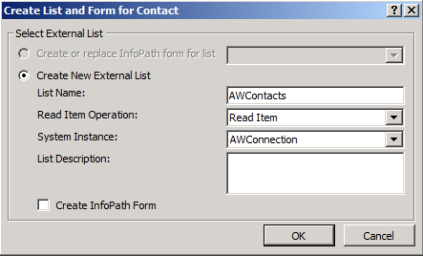

1. Verify that the external list has been created by examining the **List and Libraries** collection.

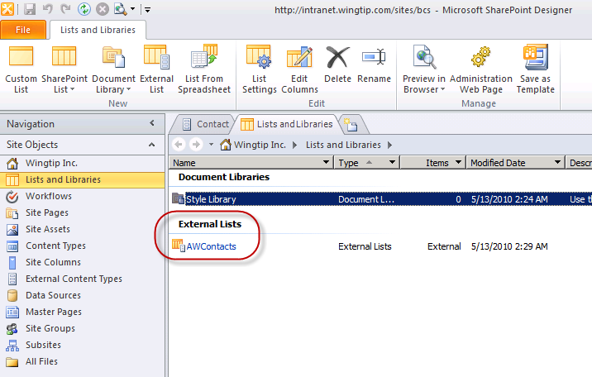

1. Once you have successfully created the **AWContacts** external list, close SharePoint Designer.

**Note:** Once the External Content Types and Related Items are created, you will have a new entity-backed list available in SharePoint. In this part of the exercise, you’ll work with the new list inside the browser.

1. Make sure you are in **Internet Explorer** inside the site **http://intranet.wingtip.com/sites/BCS.**
2. Before accessing the data defined in the external content type you just created, you first need to grant permissions to a user who can use the external content type. This is to ensure only select users can access external data.
3. Open **SharePoint 2010 Central Administration**.
4. Select **Application Management » Manage Service Applications**.
5. Select the **Business Data Connectivity Service** and click the **Manage** button in the ribbon.
6. Select the **Contact** external content type and from his ECB menu (the drop down menu when you select an item in a list), select **Set Permissions**.
7. In the top-most box enter **Administrator** and click the person check icon just below the box to validate the user:

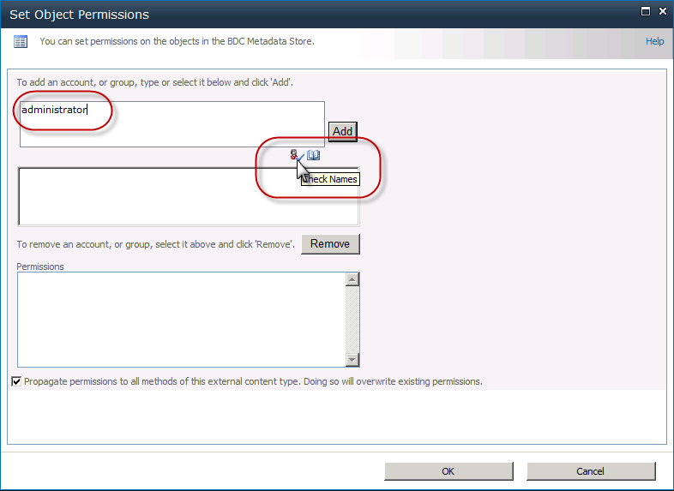

1. Once validated, click the **Add** button.
2. With the username selected, grant this user all the available permissions listed by checking each box and clicking **OK**.

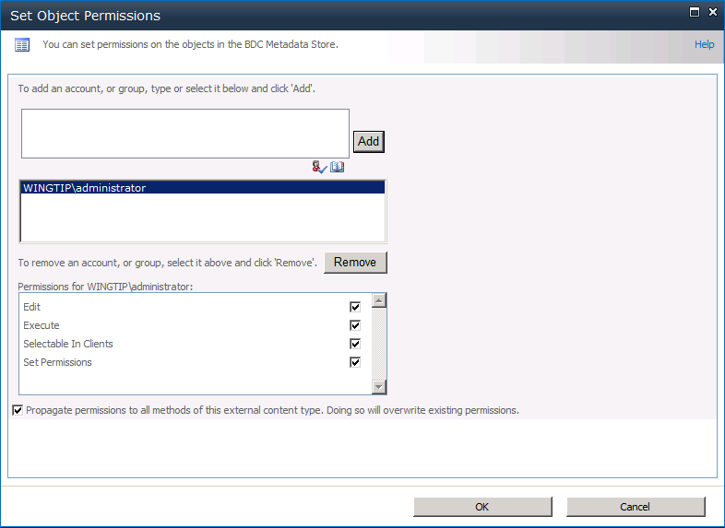

1. To have this change take effect immediately, recycle IIS by going to a command prompt and typing **IISRESET.EXE**.
2. Locate the **AWContacts** list and navigate to it in the browser. You should now see information from the **Contacts** table in the **AdventureWorks** database.

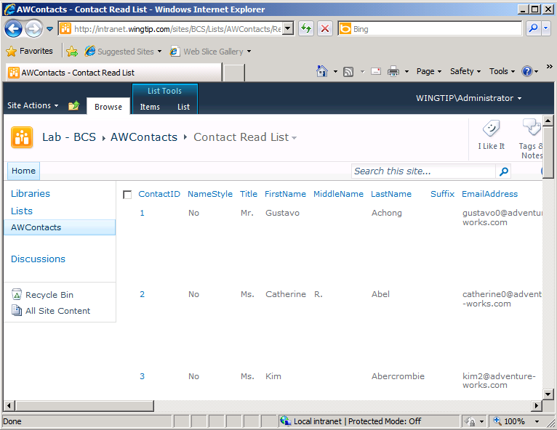

1. Now go into edit mode for the first item in the list for the contact named **Gustavo Achong**. Accomplish this by choosing the **Edit Item** command available from the ECB menu in the **ContactID** column.

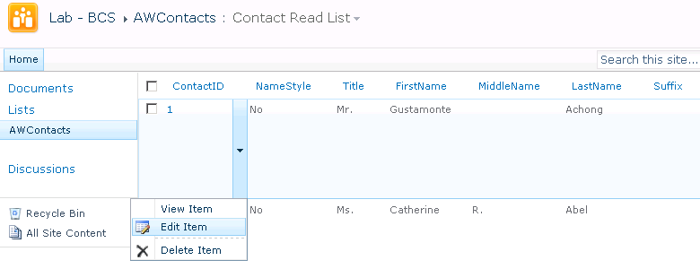

1. When the edit form appears, change the contact’s first name from **Gustavo** to **Gustamonte**. Click the **Save** button to save your changes back to the **AdventureWorks** database.



1. Verify that the external list has been updated with your changes as shown below. The main point of the last few steps is that from the user’s perspective updating items in an external list is just like updating items in a native SharePoint list.

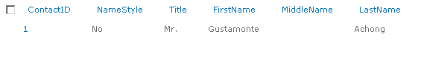

In this exercise you created an external content type and an external list surfacing data within a database as a SharePoint list.

### Exercise 2: Importing External Content Types in BCS

SharePoint Designer 2010 is the preferred method for creating External Content Types, but it is not the only method. Instead of creating ECTs in SPD, you may choose to upload an Application Definition file directly into the Business Data Connectivity (BDC) service.

1. Open **SharePoint 2010 Central Administration** in the browser.
2. On the home page, select **Manage Service Applications**.
3. On the **Manage Service Applications** page, click **Business Data Connectivity Service**.
4. On the **View External Content Types** page, you should see the **Contact** External Content Type you created in a previous exercise using the SharePoint Designer 2010.
5. Add a new external content type by importing an ECT definition.
6. Using the ribbon, select **Edit » Import**.
   1. On the **Import BDC Model** page, click the **Browse** button.
   2. Locate and open the file [[LAB FILES]]\StarterFiles\Metro_Products.xmlfile.
   3. Click the **Import** button back in the **Import BDC Model** page to upload the ECT definition file.
7. After importing the model, you might see some warnings. Disregard them and click on the **OK** button. You should see the newly defined model: **Metro_Products**.
8. Before accessing the data defined in the external content type you just created, you first need to grant permissions to a user who can use the external content type. This is to ensure only select users can access external data.
9. Select the **Metro_Products** external content type and from his ECB menu (the drop down menu when you select an item in a list), select **Set Permissions**.
10. In the top-most box enter **Administrator** and click the person check icon just below the box to validate the user:



1. Once validated, click the **Add** button.
2. With the username selected, grant this user all the available permissions listed by checking each box and clicking **OK**.



1. To have this change take effect immediately, recycle IIS by going to a command prompt and typing **IISRESET.EXE**.
2. Hover over the **Metro_Products** model, click the downward arrow to bring up the drop-down menu and pick the **View External Content Types** option.

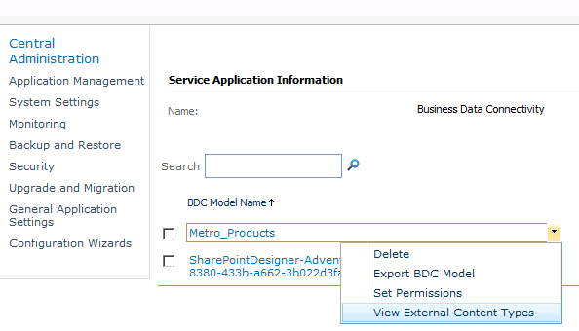

1. Notice how the View External Content Types page now shows the entity defined in the model that was imported: **Product**.

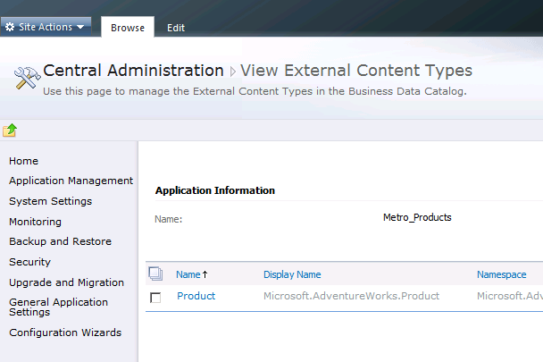

In this exercise you imported and configured the permissions for a previously created BCS model.

### Exercise 3: Expose External Content Types in Outlook

Once you have successfully created External Content Types, you may use them in several ways to create BCS applications. In this exercise, using the web browser, you will create an External List using the Contact External Content Type. Then you will connect this list to Outlook and use Outlook to change contact information

1. Using the browser navigate to the **http://intranet.wingtip.com/sites/BCS** site.
2. Click **View All Site Content** in the **Quick Launch**.
3. Click the **Create** link and then select the **External List** template.

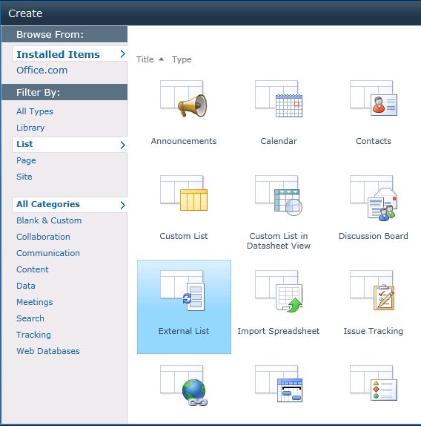

1. On the **New** page, name the list **Contacts**.
2. In the **Data Source Configuration** section, click the **Browse** button (database icon with a form behind it).
3. In the **Business Data Type Picker** dialog, select the **Contact** and click the **OK** button to select it.

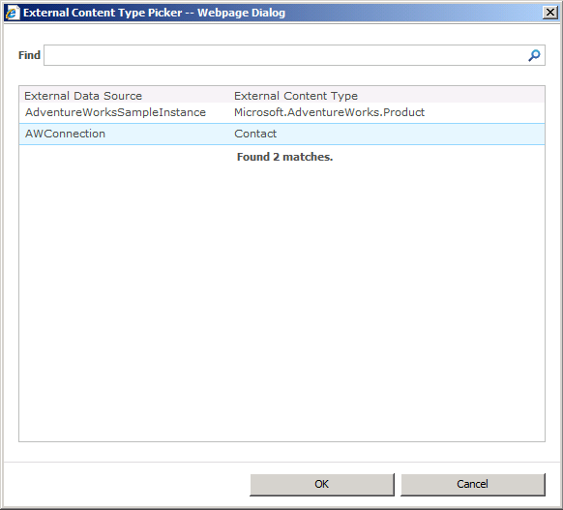

1. Click the **Create** button to finish creating the new list.

You should now see **AdventureWorks** product data presented as a list. Each **Finder** method defined in the entity will be available as a view on the list. When you have defined the proper methods, you will be able to update the list data, which will be reflected in the database.

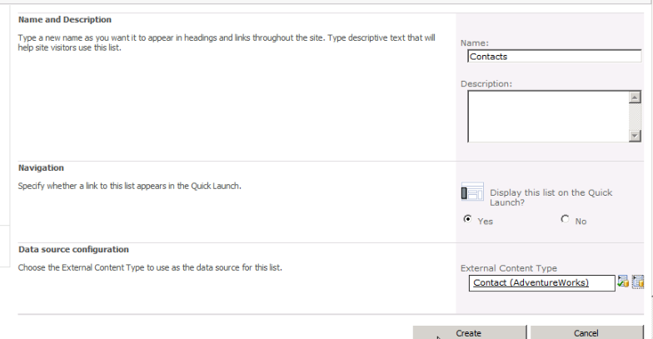

The new Contacts External List should now have been created showing the information from the Contact Table in the Adventure Works database.

You now want to connect this list to Outlook and display the contact information in Outlook.

1. Click on the **Connect to Outlook** button in the ribbon.
2. In the **Microsoft Office Customization Installer** dialog box that appears, click on **Install** button. This process might take a minute or two to complete.
3. When the Microsoft Office Customization is successfully installed, click on the **Close** button.

**Note:** When the wizard comes up and starts to setup Outlook email, choose to continue without email support. Outlook should now appear showing the Contacts information for all the contacts in the External List.

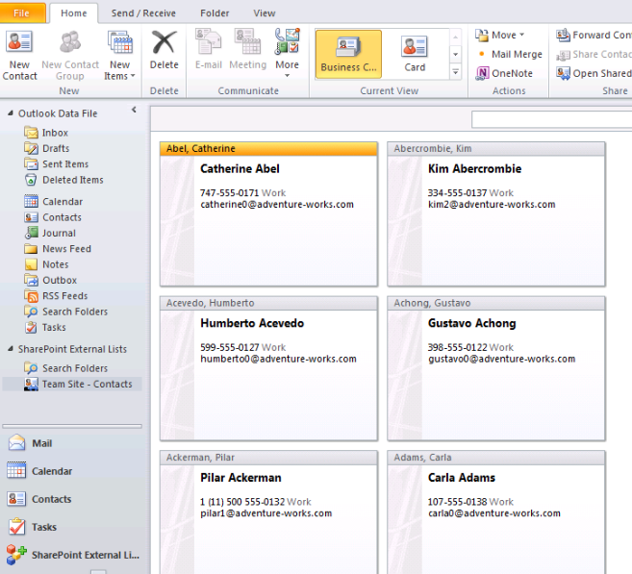

1. Click on one of the contacts to open it. Change the phone number for that contact to something else. And click on the **Save & Close** button to save the information.

The information is saved back in the Line of Business application, which in this case is the Adventure Works database’s Contact table. This change will be reflected not only within Outlook but in the external list as well as in the database.

In this exercise you created an external list and synchronized it with Outlook 2010.

### Exercise 4: Create Quick Parts in a Microsoft Word Template to Expose Line of Business Data

In this exercise, you will expose the data from your Line of Business application (the AdventureWorks database in this case) directly in a Microsoft Word document using the Quick Parts functionality.

1. Using the browser navigate to the **http://intranet.wingtip.com/sites/BCS** site.
2. Click on the **Shared Documents** link in the **Quick Launch**.
3. Once at the Shared Documents library, use the ribbon to and within the **Library Tools** contextual tab group, click **Library** **» Create Column**.
4. In the **Create Column** dialog box that appears, use the following information to complete the field:

**Column Name:** Contact

**Type of information in this column is:** External Data

**External Content Type:** Contact External Content Type

**Select the Field to be shown on this column drop-down:** LastName

**Add a column to show each of these additional fields:** EmailAddress, FirstName, Phone

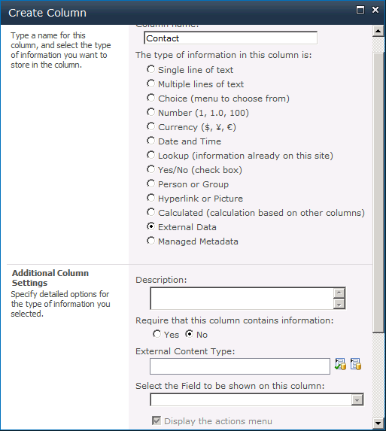

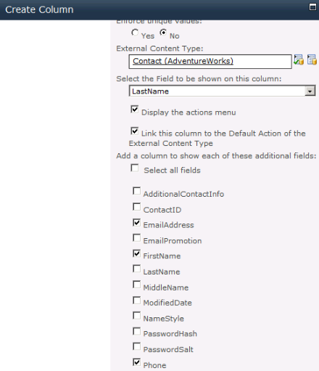

Now you will edit the Word document template that this library has to insert Quick Parts, which will point to the external data in the Adventure Works database.

1. In the ribbon click **Library Settings » Advanced Settings**.
2. In the **Document Template** section, click on the **Edit Template** link. The **Open Document** dialog box appears. Click on the **OK** button.
3. Word 2010 will open showing the document template that is associated with this library. Create a table and add the following labels into the left column of the page:

Last Name

First Name

Email

Phone

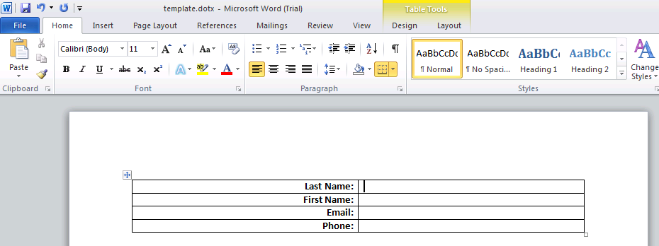

1. Put the cursor after the **Last Name** label, and in the ribbon select **Insert » Quick Parts**. Hover over the **Document Property** selection, you should see all the properties which are available for this document including the External Data properties. Click on the **Contact** property. It should now appear after the Last Name label.

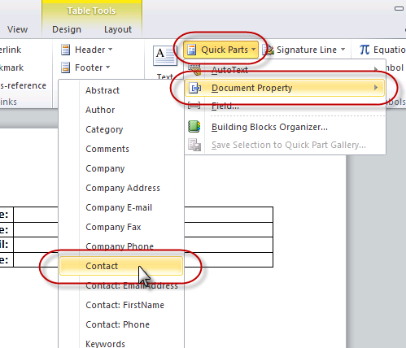

1. Put your cursor after the **First Name** label, click **Insert »** **Quick Parts » Document Property » Contact: FirstName**.
2. In the same manner, go ahead and select **Email** and **Phone** and insert them after the appropriate labels.
3. Once you are done inserting all the Document Properties, you are ready to save this document. Click on the **Save** button and **Close** the Word document template.

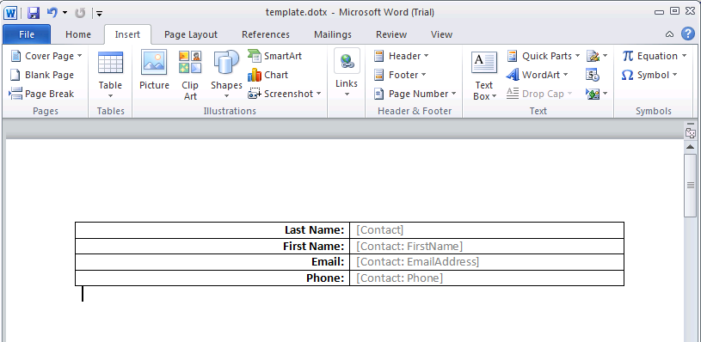

1. Click on the **Shared Documents** link in the breadcrumb navigation to go back to the Shared Documents library.
2. Click on the **Documents** tab and then click on **New Document** button in the ribbon.
3. In the **Open Document** dialog box, click on **OK**. The Word document template will open up for the user.
4. Click on the **Contact** document property that was inserted earlier, you should see that there is a **Browse** button to be able to browse the External Data.

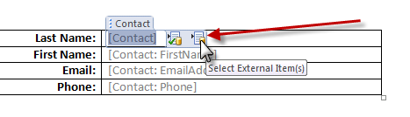

1. Click on the **Browse** button. The **Choose External Data** dialog box appears showing you the external data from the Line of Business application, which in our case is the Contact table from the Adventure Works database.
2. Pick the name **Ackerman** and click **OK**.
3. You should see that the **First Name**, **Email Address** and the **Phone** should have automatically been filled in now when the **Last Name** was selected.

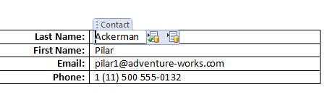

1. Click on the **Save** icon to save this document and save this document as **Ackerman**.
2. **Close** the Microsoft Word 2010.

The new file called Ackerman should now be displayed in the Document library, and in the columns, the Contact’s Last Name, Email Address, First Name and Phone should all appear. This data is coming directly from your Line of Business application (in this case, the Contact table in Adventure Works database).

In this exercise you modified a document template in a document library to include data from an external content type that was leveraged in a Word document using Quick Parts.